Lab Taks-1

Question-
Draw the object-

Graph Plot (Picture)-
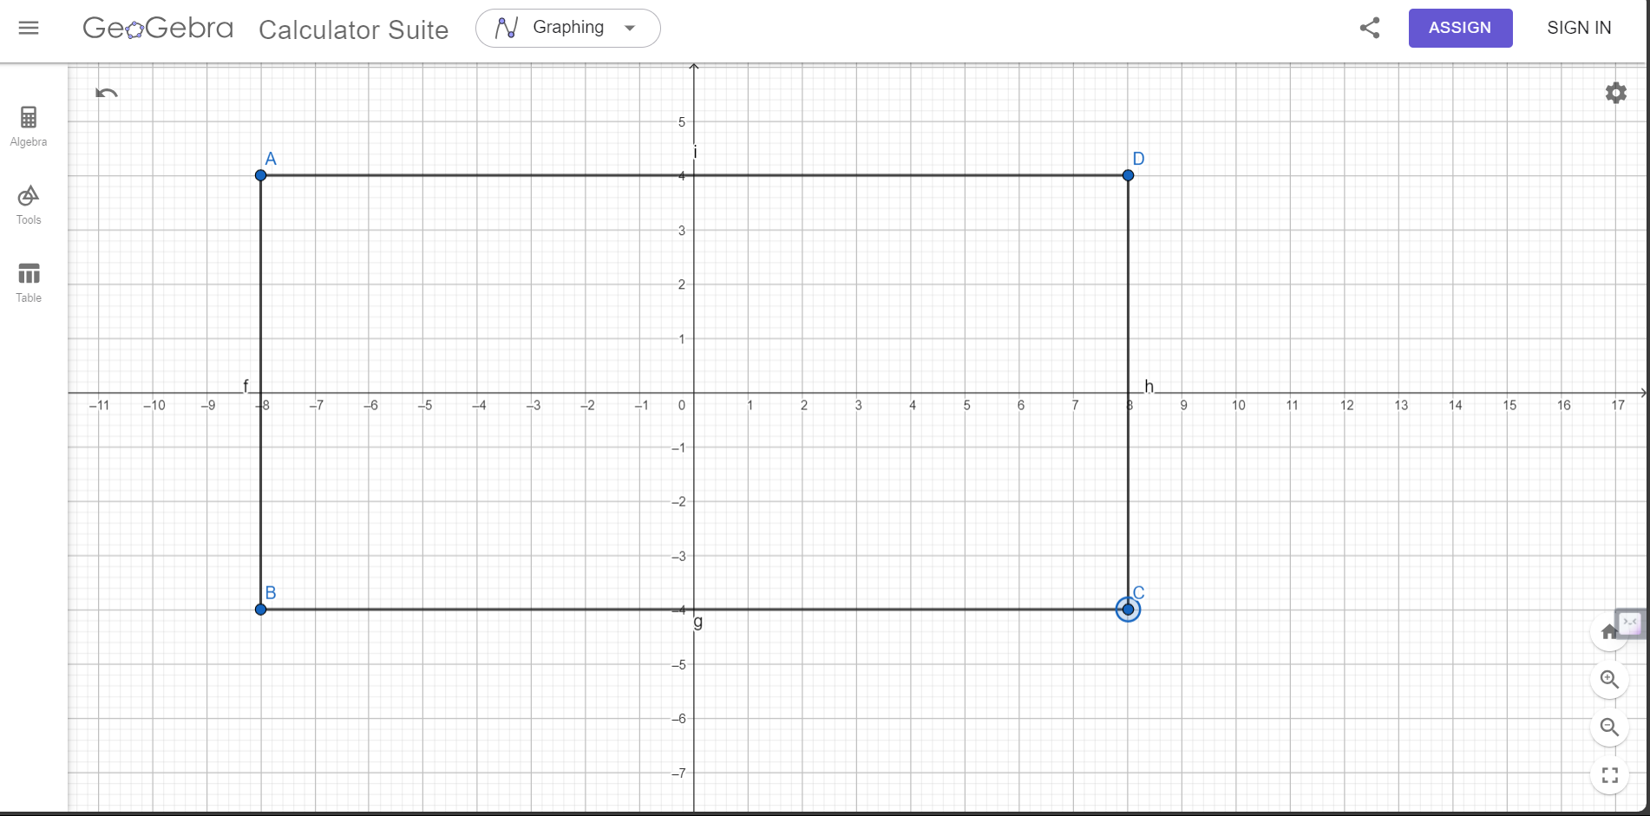

Code-
#include <windows.h>
#include <GL/glut.h>

void display() {

glClearColor(1.0f, 1.0f, 1.0f, 1.0f);

glClear(GL_COLOR_BUFFER_BIT);

glLineWidth(5);

glBegin(GL_LINES);

glColor3f(0.0f, 0.0f, 0.0f);
glVertex2f(-.8f, .4f);

glVertex2f(.8f, .4f);

glEnd();

glBegin(GL_LINES);

glColor3f(0.0f, 0.0f, 0.0f);

glVertex2f(.8f, .4f);
glVertex2f(.8f, -.4f);

glEnd();

glBegin(GL_LINES);

glColor3f(0.0f, 0.0f, 0.0f);

glVertex2f(.8f, -.4f);

glVertex2f(-.8f, -.4f);

glEnd();
glBegin(GL_LINES);

glColor3f(0.0f, 0.0f, 0.0f);

glVertex2f(-.8f, -.4f);

glVertex2f(-.8f, .4f);

glEnd();
glFlush();

}

int main(int argc, char** argv) {

glutInit(&argc, argv);

glutCreateWindow("OpenGL Setup");

glutInitWindowSize(5000, 4000);

glutDisplayFunc(display);
glutMainLoop();

return 0;

}

Output Screenshot (Full Screen)-
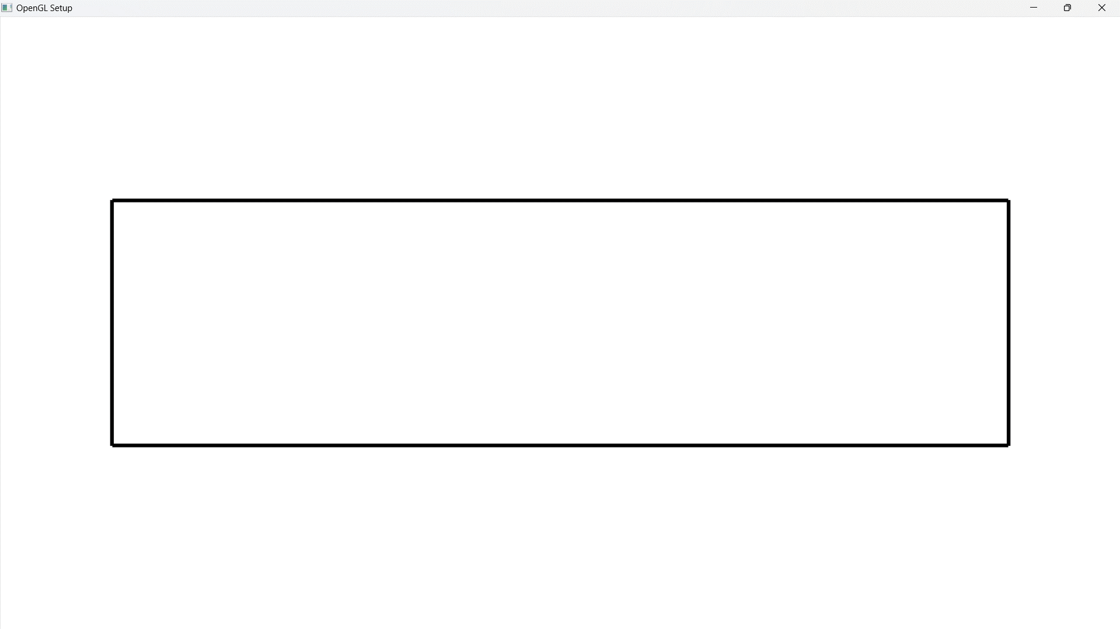

Question-
Draw the object-

Graph Plot (Picture)-

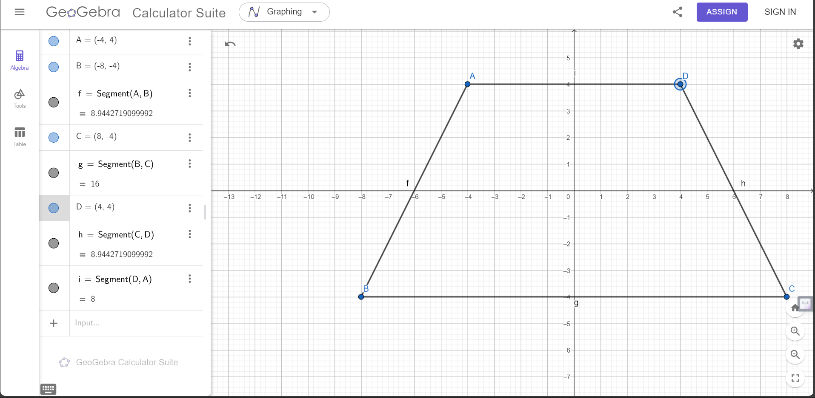

Code-

#include <windows.h>
#include <GL/glut.h>

void initGL() {

glClearColor(1.0f, 1.0f, 1.0f, 1.0f);
}

void display() {

glClear(GL_COLOR_BUFFER_BIT);
glClearColor(1.0f, 1.0f, 1.0f, 1.0f);

glBegin(GL_POLYGON);

glColor3f(1.0f, 0.0f, 0.0f);

glVertex2f(-0.4f, 0.4f);
glVertex2f(0.4f, 0.4f);

glVertex2f(-0.8f, -0.4f);
glVertex2f(-0.4f, 0.4f);

glVertex2f(-0.8f, -0.4f);
glVertex2f(0.8f, -0.4f);

glVertex2f(0.8f, -0.4f);
glVertex2f(0.4f, 0.4f);

glEnd();

glFlush();

}

int main(int argc, char** argv) {

glutInit(&argc, argv);

glutInitWindowSize(1000, 800);

glutCreateWindow("OpenGL Setup Test");

glutDisplayFunc(display);

glutMainLoop();

return 0;

}

Output Screenshot (Full Screen)-
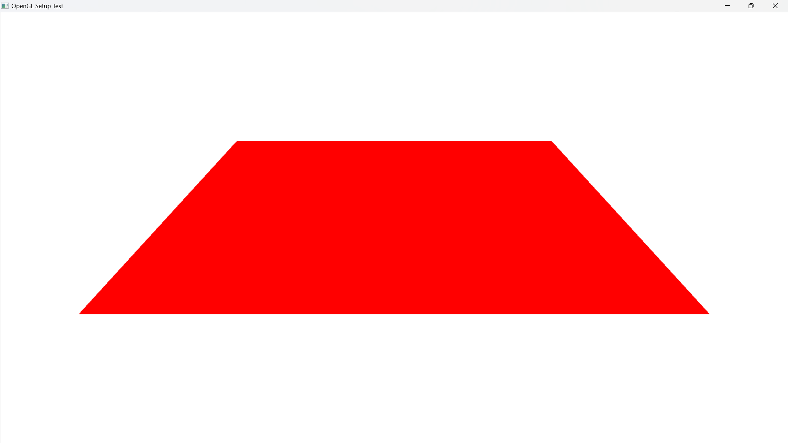

Question-
Draw the object-
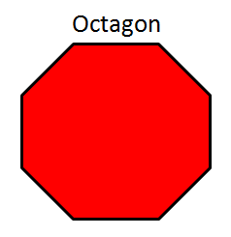

Graph Plot (Picture)-
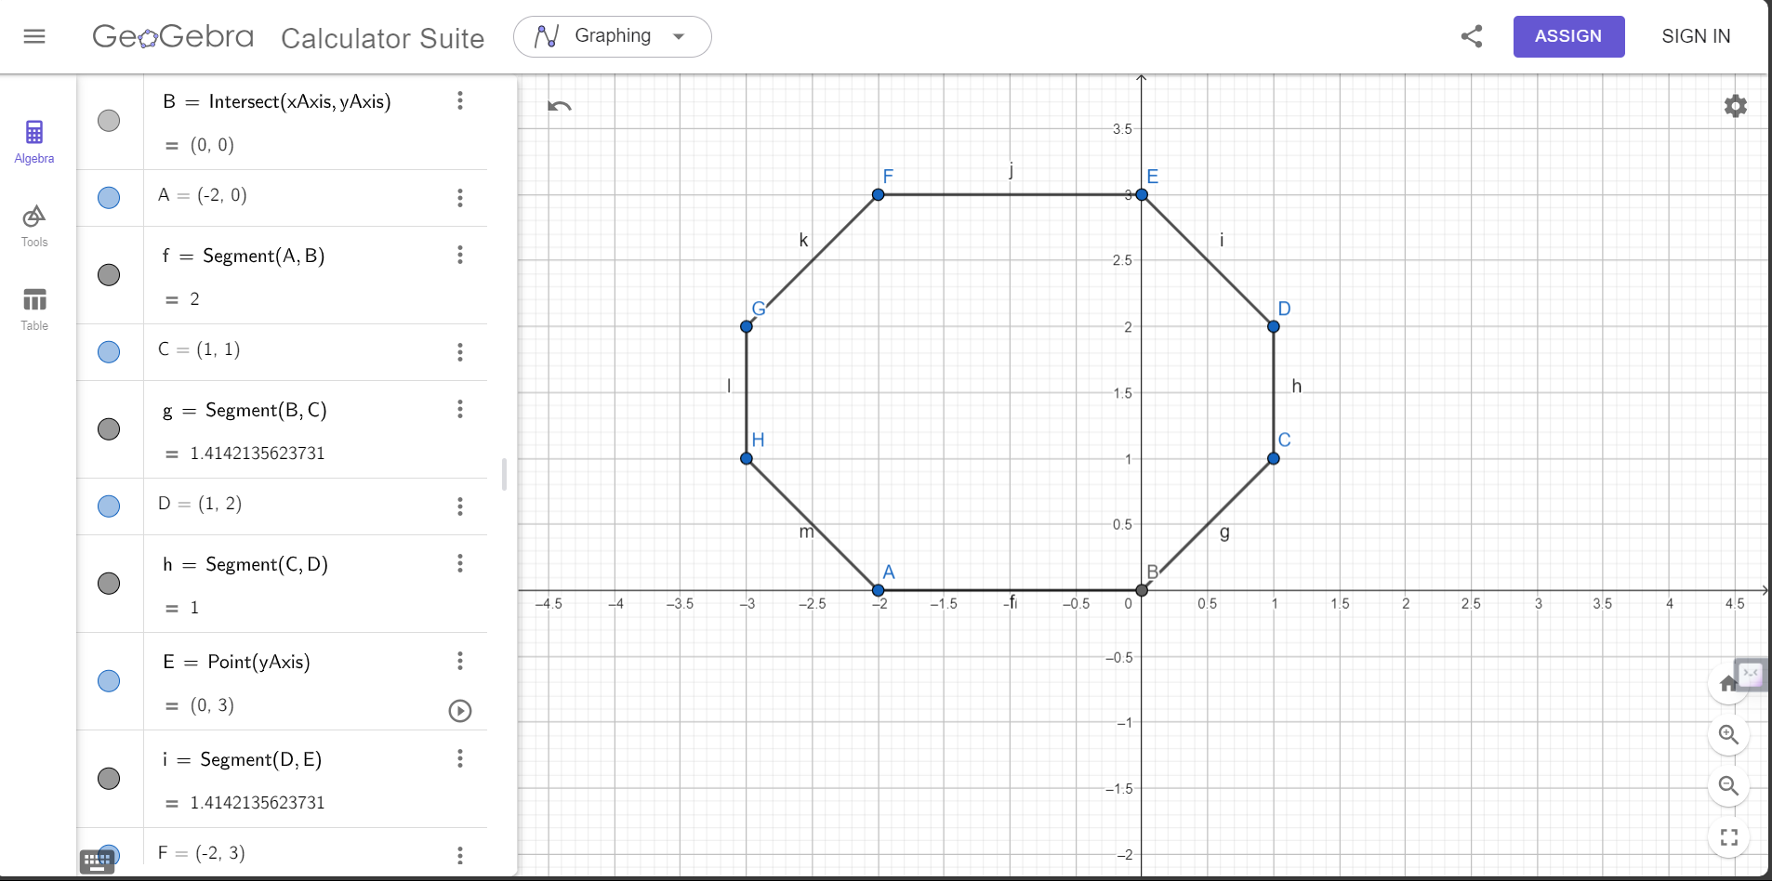

Code-

#include <windows.h>
#include <GL/glut.h>

void initGL() {

glClearColor(1.0f, 1.0f, 1.0f, 1.0f);
}

void display() {

glClear(GL_COLOR_BUFFER_BIT);
glClearColor(1.0f, 1.0f, 1.0f, 1.0f);

glBegin(GL_POLYGON);

glColor3f(1.0f, 0.0f, 0.0f);

glVertex2f(-0.2f, 0.0f);
glVertex2f(0.0f, 0.0f);

glVertex2f(0.0f, 0.0f);
glVertex2f(0.1f, 0.1f);

glVertex2f(0.1f, 0.1f);
glVertex2f(0.1f, 0.2f);

glVertex2f(0.1f, 0.2f);
glVertex2f(0.0f, 0.3f);

glVertex2f(0.0f, 0.3f);
glVertex2f(-0.2f, 0.3f);

glVertex2f(-0.2f, 0.3f);
glVertex2f(-0.3f, 0.2f);

glVertex2f(-0.3f, 0.2f);
glVertex2f(-0.3f, 0.1f);

glVertex2f(-0.3f, 0.1f);
glVertex2f(-0.2f, 0.0f);

glEnd();

glLineWidth(2);

glBegin(GL_LINES);
glColor3f(0.0f, 0.0f, 0.0f);

glVertex2f(-0.2f, 0.0f);
glVertex2f(0.0f, 0.0f);

glVertex2f(0.0f, 0.0f);
glVertex2f(0.1f, 0.1f);

glVertex2f(0.1f, 0.1f);
glVertex2f(0.1f, 0.2f);

glVertex2f(0.1f, 0.2f);
glVertex2f(0.0f, 0.3f);

glVertex2f(0.0f, 0.3f);
glVertex2f(-0.2f, 0.3f);

glVertex2f(-0.2f, 0.3f);
glVertex2f(-0.3f, 0.2f);

glVertex2f(-0.3f, 0.2f);
glVertex2f(-0.3f, 0.1f);

glVertex2f(-0.3f, 0.1f);
glVertex2f(-0.2f, 0.0f);

glEnd();
glFlush();

}

int main(int argc, char** argv) {

glutInit(&argc, argv);

glutInitWindowSize(1000, 800);

glutCreateWindow("OpenGL Setup Test");

glutDisplayFunc(display);

glutMainLoop();

return 0;

}

Output Screenshot (Full Screen)-
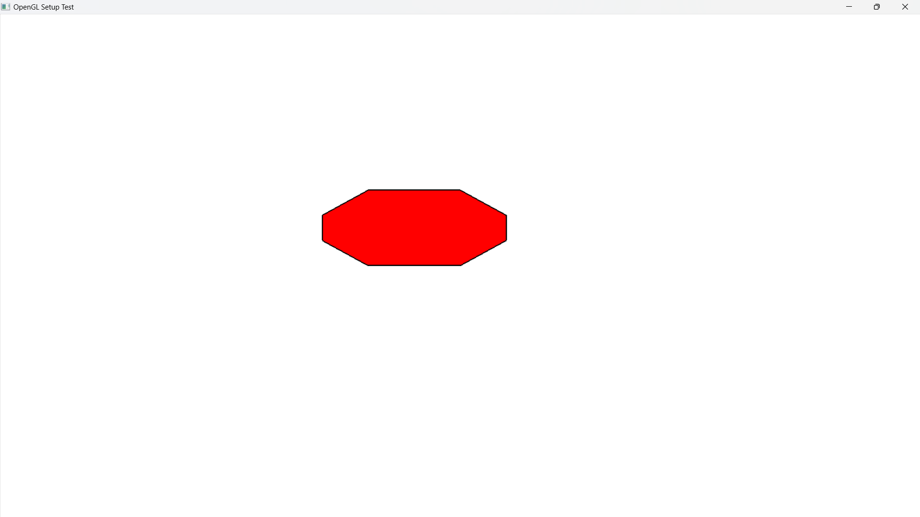

Question-
Draw the object-

Graph Plot (Picture)-

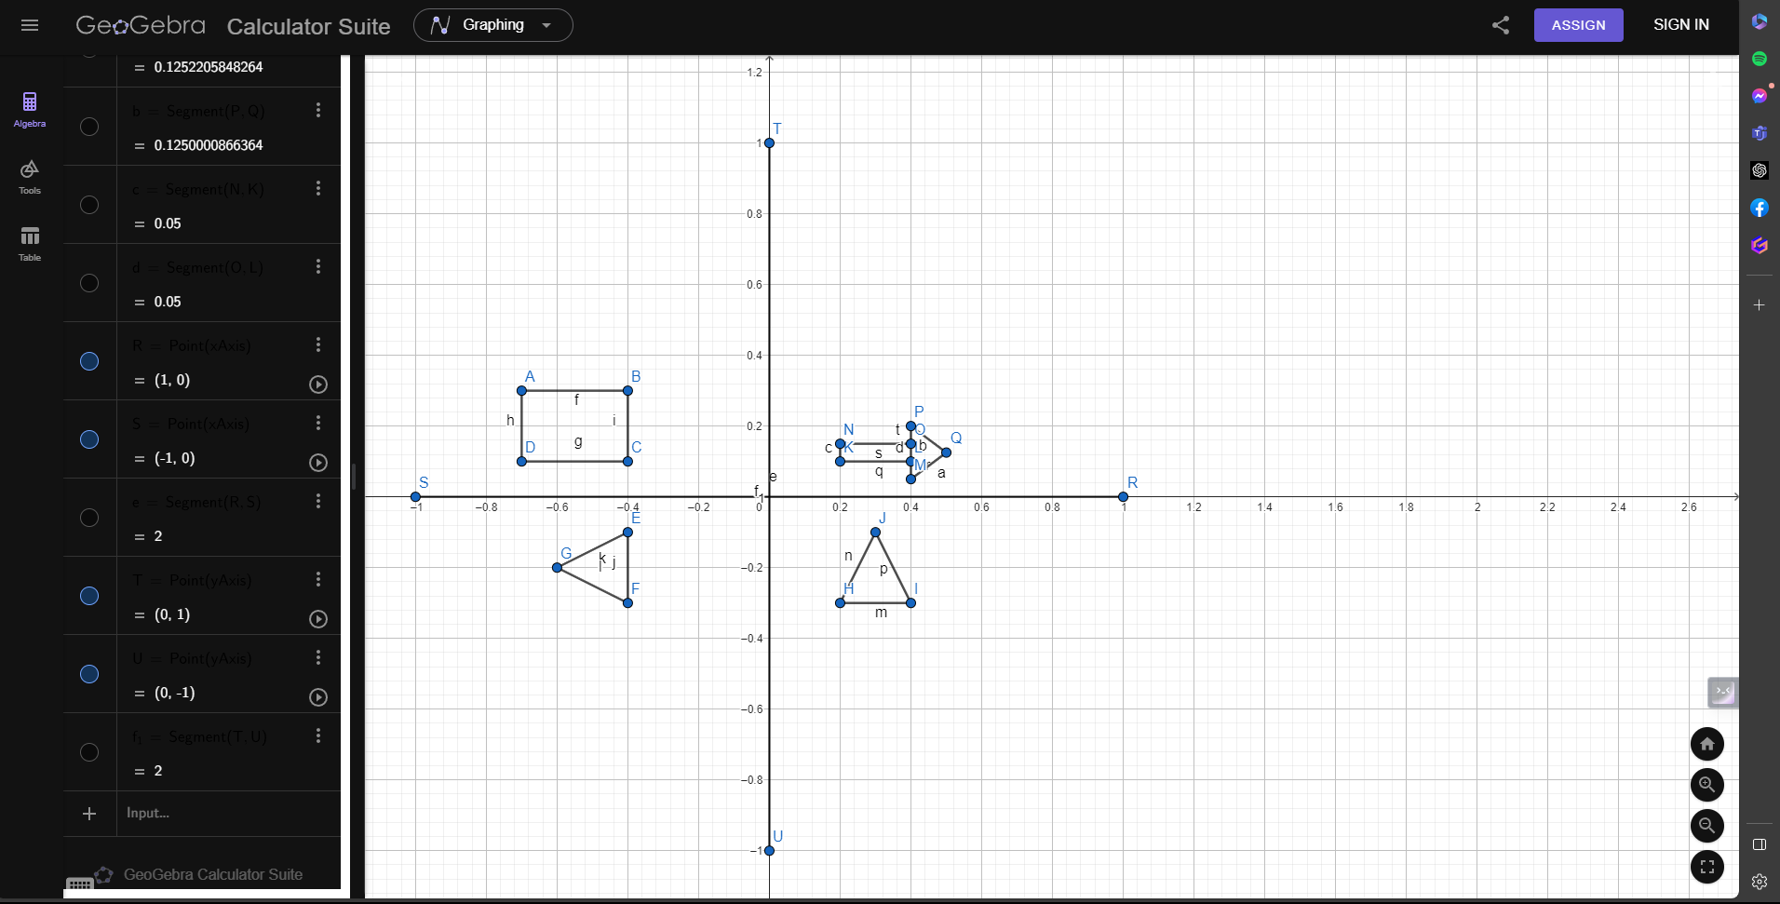
Code-
#include <windows.h>

#include <GL/glut.h>

void initGL() {

glClearColor(0.0f, 0.0f, 0.0f, 0.0f);

}

void display() {

glClear(GL_COLOR_BUFFER_BIT);
glClearColor(1.0f, 1.0f, 1.0f, 1.0f);

glBegin(GL_QUADS);
glColor3f(1.0f, .0f, 0.0f);
glVertex2f(-0.7f, 0.3f);
glVertex2f(-0.4f, 0.3f);
glVertex2f(-0.4f, 0.3f);
glVertex2f(-0.4f, 0.1f);
glVertex2f(-0.4f, 0.1f);
glVertex2f(-0.7f, 0.1f);
glVertex2f(-0.7f, 0.1f);
glVertex2f(-0.7f, 0.3f);
glEnd();

glBegin(GL_TRIANGLES);
glColor3f(0.35f, 0.15f, 0.50f);
glVertex2f(-0.6f, -0.2f);
glVertex2f(-0.4f, -0.1f);
glVertex2f(-.4f, -0.3f);
glEnd();

glBegin(GL_QUADS);
glColor4f(1.0f, 1.0f, 0.0f, 0.0f);
glVertex2f(0.3f, -0.1f);
glVertex2f(0.4f, -0.3f);
glVertex2f(0.4f, -0.3f);
glVertex2f(0.2f, -0.3f);
glVertex2f(0.2f, -0.3f);
glVertex2f(0.3f, -0.1f);
glEnd();

glBegin(GL_QUADS);
glColor3f(0.0f, 1.0f, 0.0f);
glVertex2f(0.2f, 0.15f);
glVertex2f(0.2f, 0.1f);
glVertex2f(0.2f, 0.1f);
glVertex2f(0.4f, 0.1f);
glVertex2f(0.4f, 0.1f);
glVertex2f(0.4f, 0.15f);
glVertex2f(0.4f, 0.15f);
glVertex2f(0.2f, 0.15f);
glEnd();
glFlush();

glBegin(GL_QUADS);
glColor3f(0.0f, 1.0f, 0.0f);

glVertex2f(0.4f, 0.2f);
glVertex2f(0.4f, 0.05f);

glVertex2f(0.4f, 0.05f);
glVertex2f(0.5001377772798, 0.1251839106838f);

glVertex2f(0.5001377772798, 0.1251839106838f);
glVertex2f(0.4f, 0.2f);
glEnd();
glFlush();

glBegin(GL_QUADS);
glColor3f(0.0f, 1.0f, 0.0f);
glVertex2f(0.4f, 0.2f);
glVertex2f(0.4f, 0.05f);
glVertex2f(0.4f, 0.05f);
glVertex2f(0.5001377772798, 0.1251839106838f);
glVertex2f(0.5001377772798, 0.1251839106838f);
glVertex2f(0.4f, 0.2f);
glEnd();
glFlush();

glBegin(GL_LINES);
glLineWidth(10);
glColor3f(0.0f, 0.5f, 0.5f);
glVertex2f(0.0f, 1.0f);
glVertex2f(.0f, -1.0f);
glVertex2f(1.0f, 0.0f);
glVertex2f(-1.0f, 0.0f);
glEnd();
glFlush();

glEnd();

}

int main(int argc, char** argv) {

glutInit(&argc, argv);

glutCreateWindow("Vertex, Primitive & Color");

glutInitWindowSize(320, 320);

glutDisplayFunc(display);

initGL();

glutMainLoop();

return 0;

}

Output Screenshot (Full Screen)-
